Homework 5 Austin Frownfelter

# Problem 1

## (C)

|  |  |  |  |  |
| --- | --- | --- | --- | --- |
|  | Train |  | Test |  |
|  | 1 | 0 | 1 | 0 |
| 1 | 115 | 40 | 42 | 19 |
| 0 | 85 | 299 | 26 | 142 |
|  | Sens | Spec | Sens | Spec |
|  | 0.575 | 0.882 | 0.6176 | 0.882 |
|  | Misclass | 0.2319 | Misclass | 0.1965 |

## (D)

|  |  |  |  |  |
| --- | --- | --- | --- | --- |
| SVML | Mis Train | 0.2319 | Mis Test | 0.1965 |
| Log Reg | Mis Train | 0.2988 | Mis Test | 0.2722 |
| Naïve Bayes | Mis Train | 0.4644 | Mis Test | 0.3759 |
|  |  |  |  |  |
| SVML | Sens Train | 0.575 | Sens Test | 0.6176 |
|  | Spec Train | 0.882 | Spec Test | 0.882 |
| Log Reg | Sens Train | 0.59 | Sens Test | 0.6765 |
|  | Spec Train | 0.876106 | Spec Test | 0.8323 |
| Naïve Bayes | Sens Train | 0.84 | Sens Test | 0.8676 |
|  | Spec Train | 0.539823 | Spec Test | 0.5093 |

In all cases, the SVML performed better than both Logistic Regression and Naïve Bayes from my assignment 5 (Sensitivity is lower, specificity is higher).

## (E)

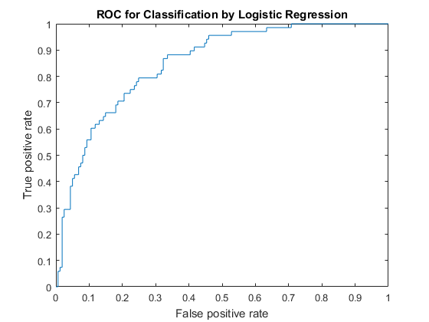

AUC for SVML: 0.8497. AUC for logistic/naïve Bayes: 0.8518, 0.555. The logistic AUC is only slightly better than the SVML AUC, but both are significantly better than my naïve Bayes. Therefore, the logistic model is technically better.